SCREENSHOTS

|  |  |
| --- | --- |
| DATE | 7 November 2022 |
| PROJECT NAME | Web phishing detection |
| TEAM ID | PNT2022TMID24961 |

HOME PAGE:

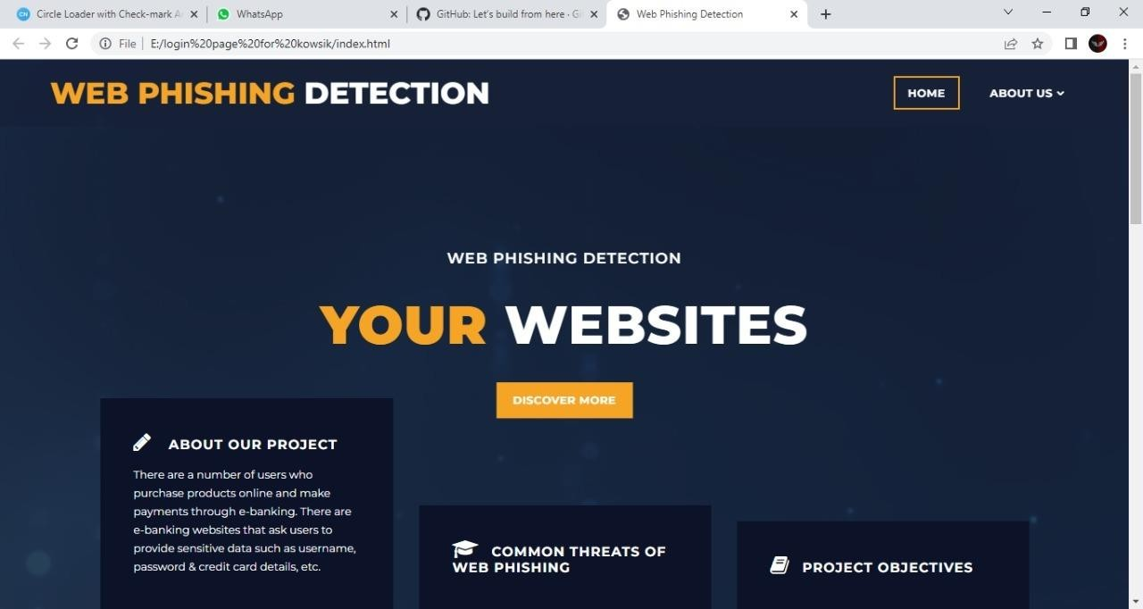

ABOUT

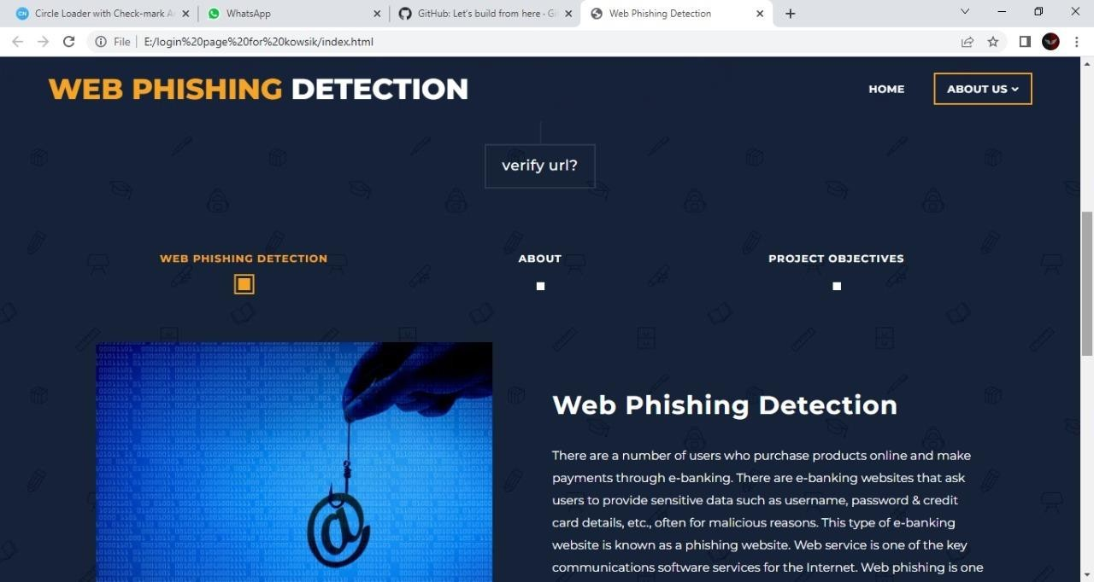

REGISTRATION PAGE :

